**Pokoloruj:**

[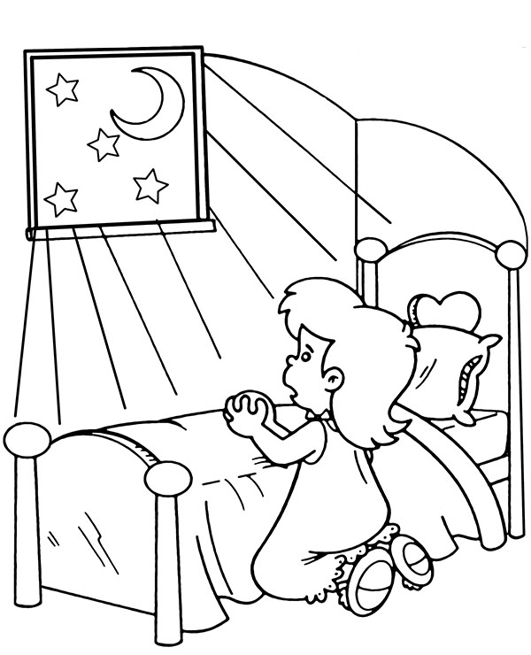](https://www.google.pl/url?sa=i&url=https%3A%2F%2Fwww.e-kolorowanki.eu%2Fchrzescijanskie%2Fmodlitwa-wieczorna%2F&psig=AOvVaw2J8r7bJYnBsTYk6ZQh06h2&ust=1584776096119000&source=images&cd=vfe&ved=0CAIQjRxqFwoTCNi6oZXFqOgCFQAAAAAdAAAAABAD)